**Window Object**

1. Innerwidth

It gives the entire width of the webpage.

i )

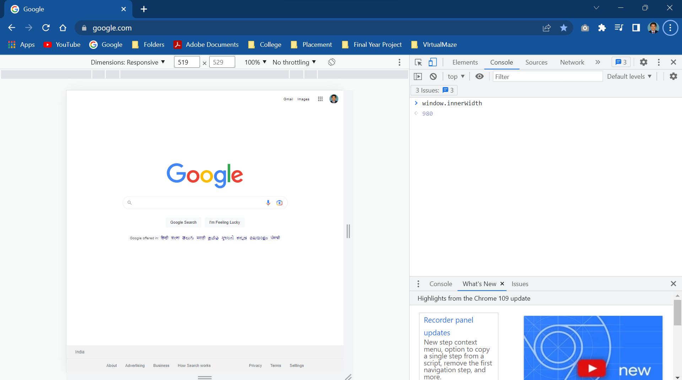

ii ) InnerWidth

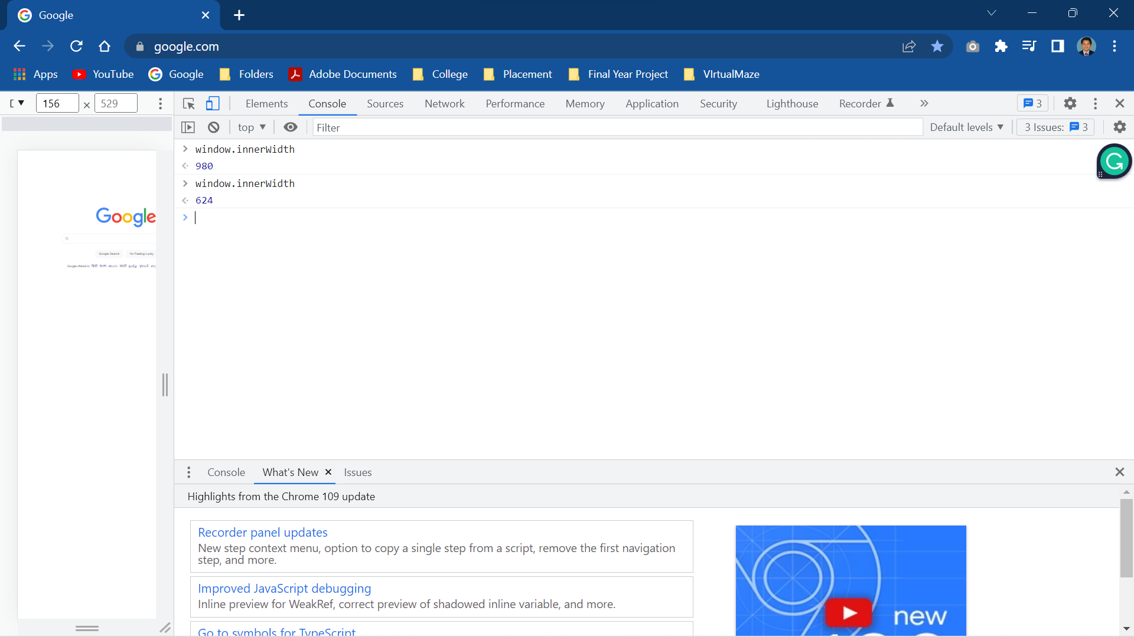

1. OuterWidth

It is showing the Entire Width of the Browser , so that if you reduce the the webpage it does not change the value.

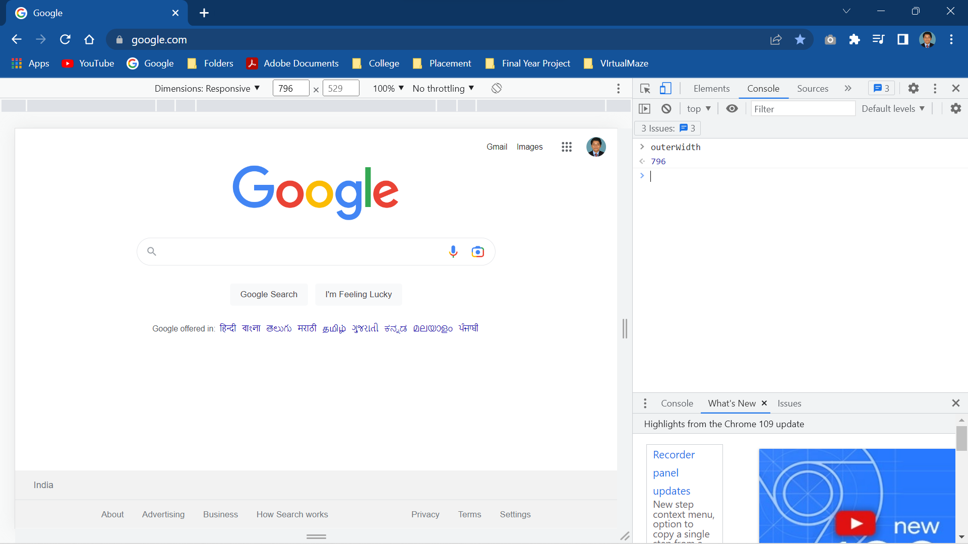

1. InnerHeight

It shows the entire height of the webpage.

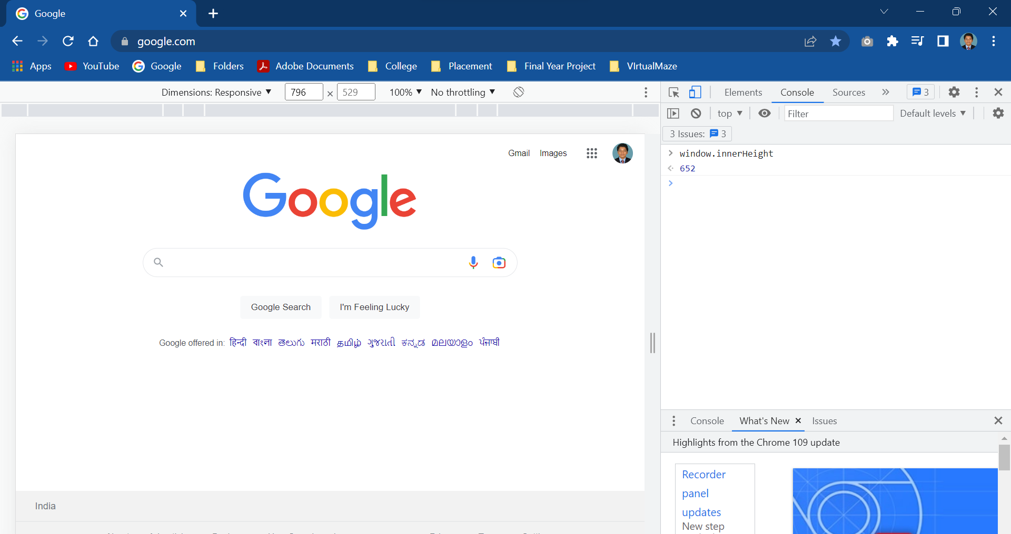

4.OuterHeight

If you reduce the window size it will change the value.

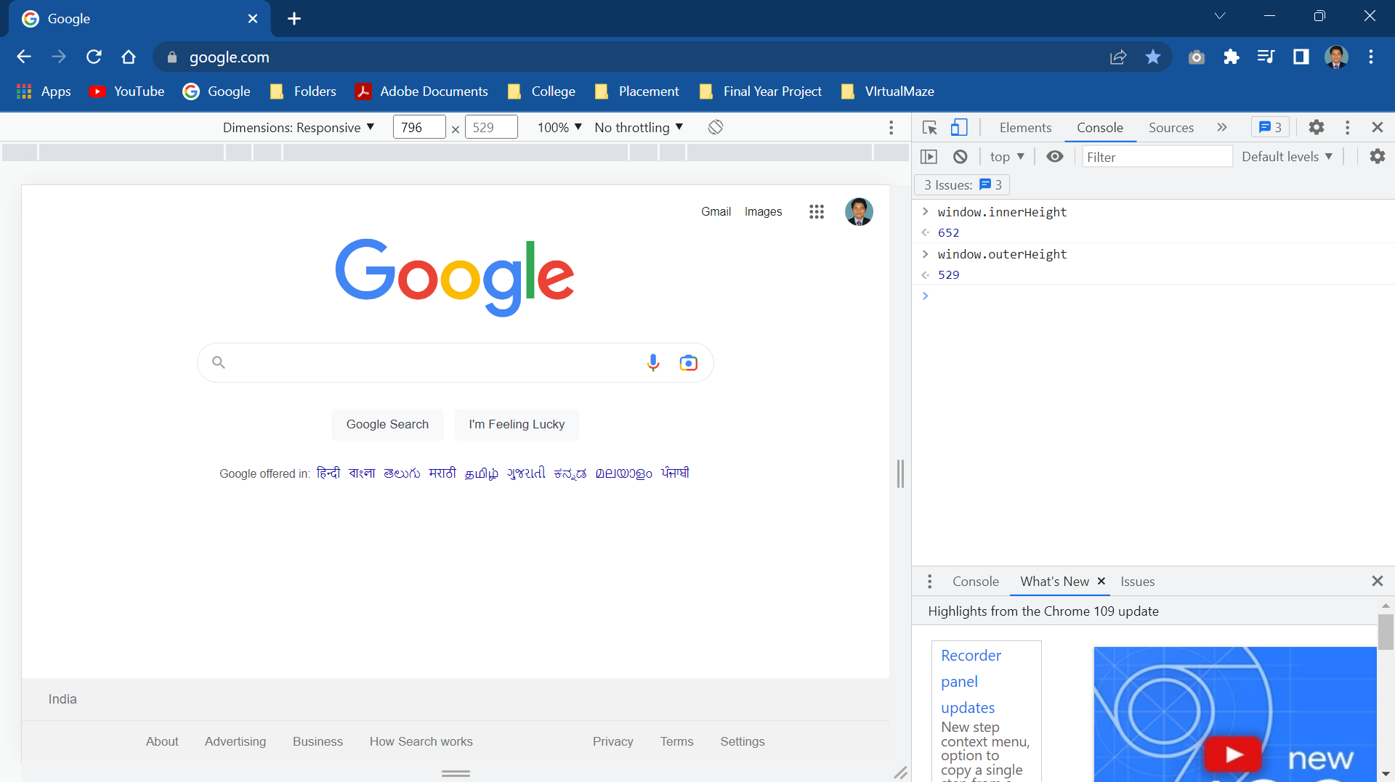

5. LocalStorage

Whenever you close the tab or Window it will remains same.

6. SessionStorage

Whenever you close the tab or window it will automatically delete from storage.

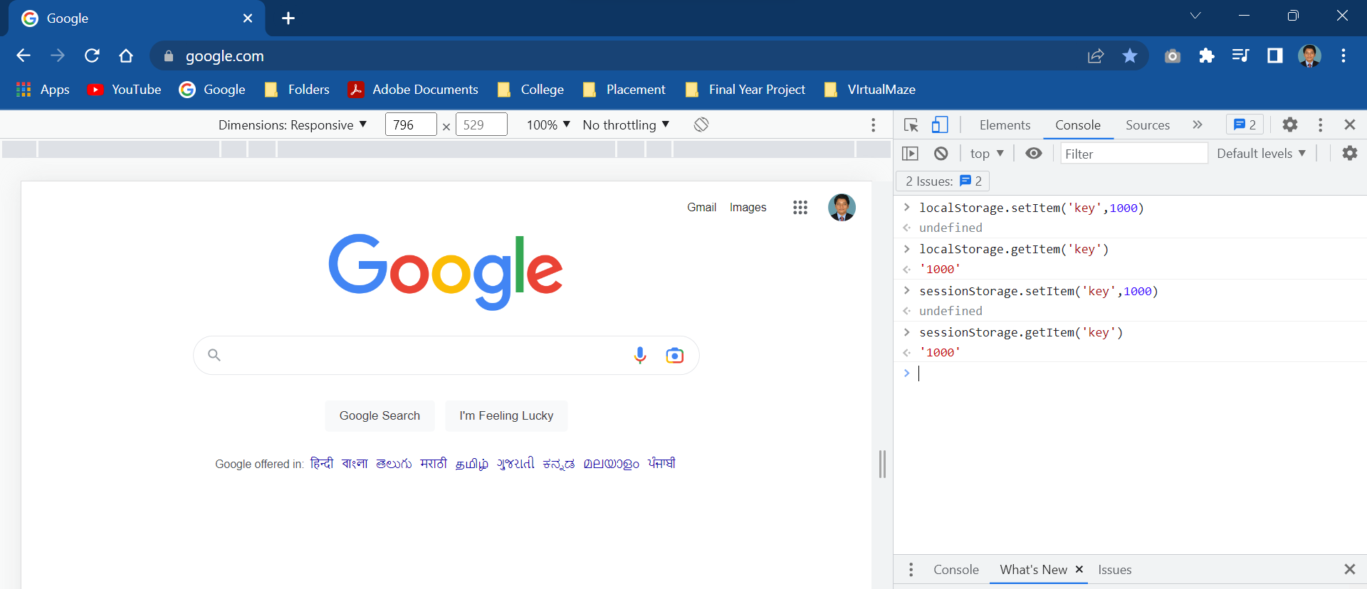

7.**Window.location**

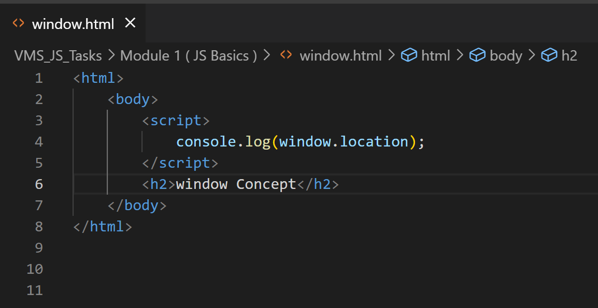

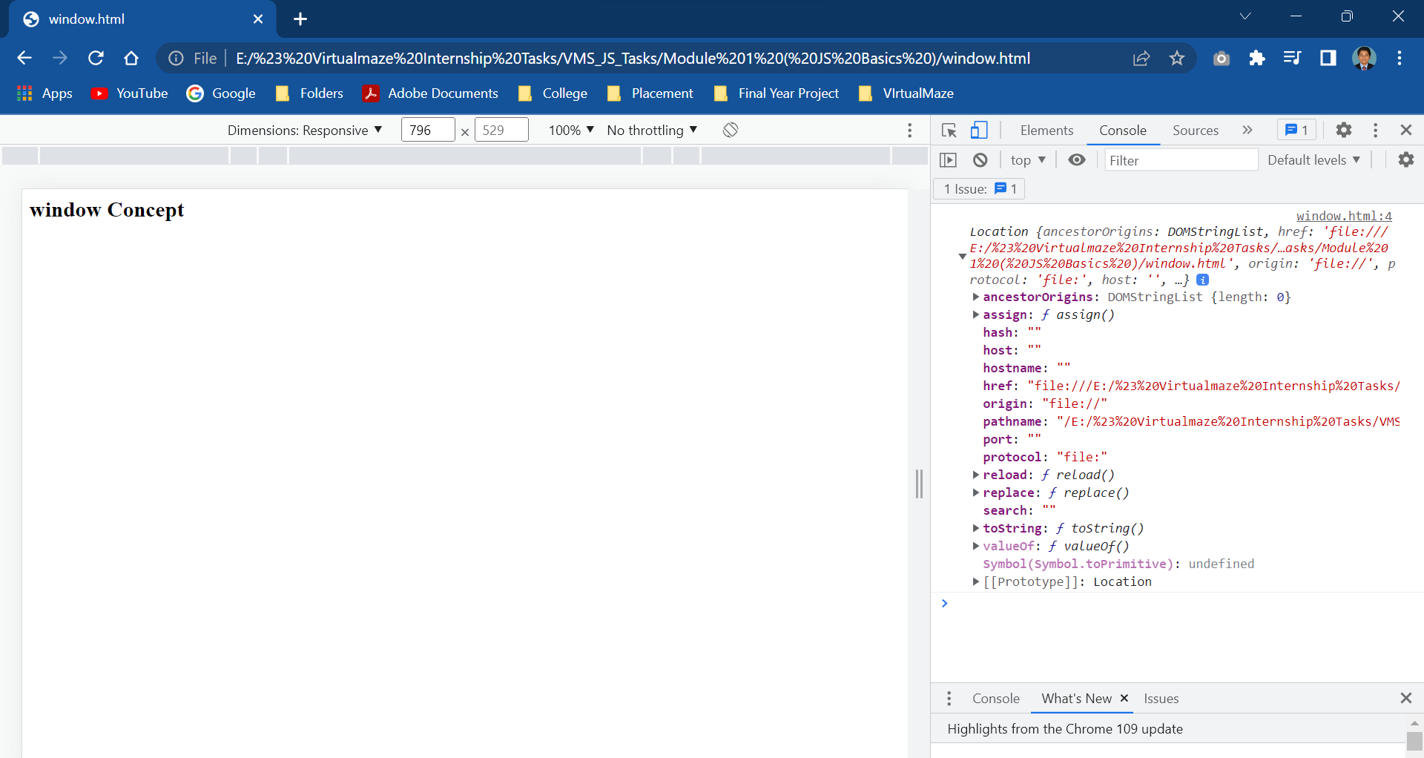

**Document Object**

